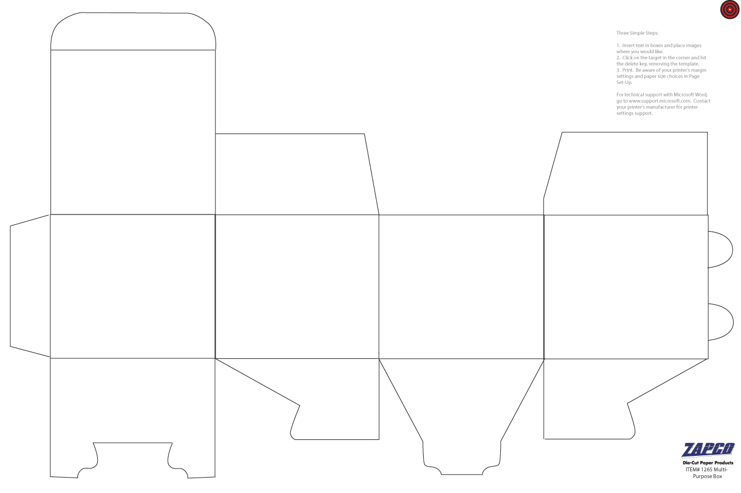

TOP OF BOX. Be sure that your artwork is upside down in this box.

Enter Text and Images In this Box. Copy and paste onto the other panels of the Box as you see fit.