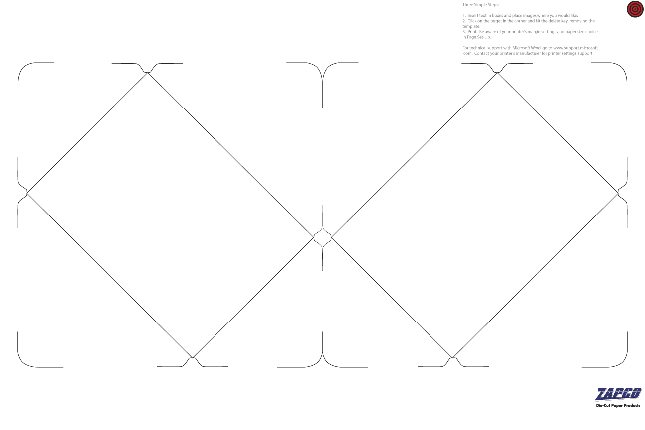

Insert Text and Images Here

Insert Text and Images Here